Rubric Form
B.Sc (Hons) Degree Program
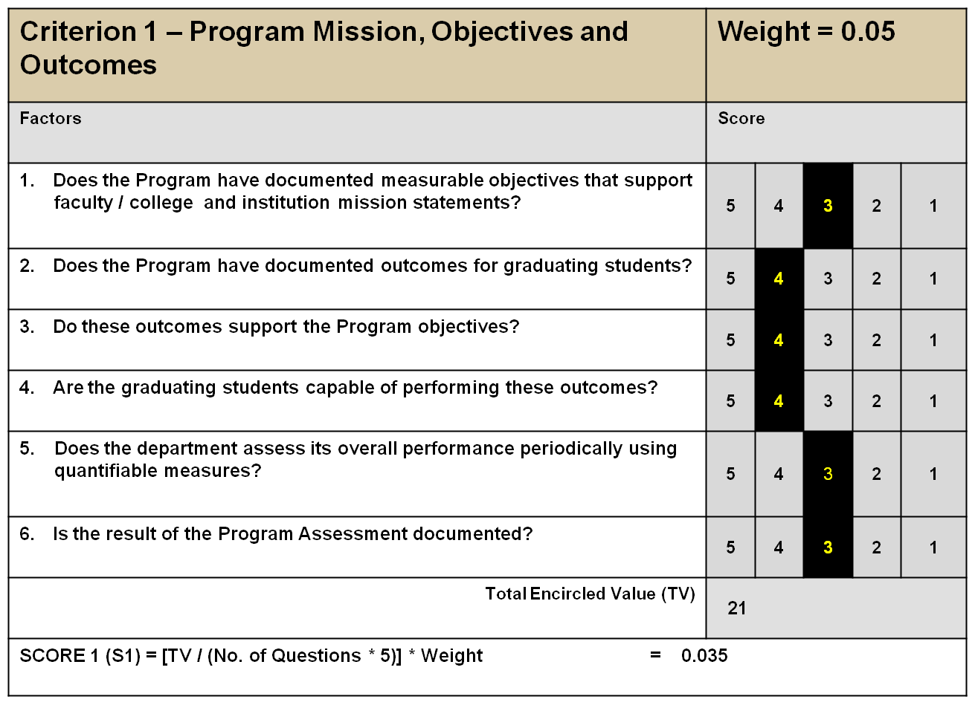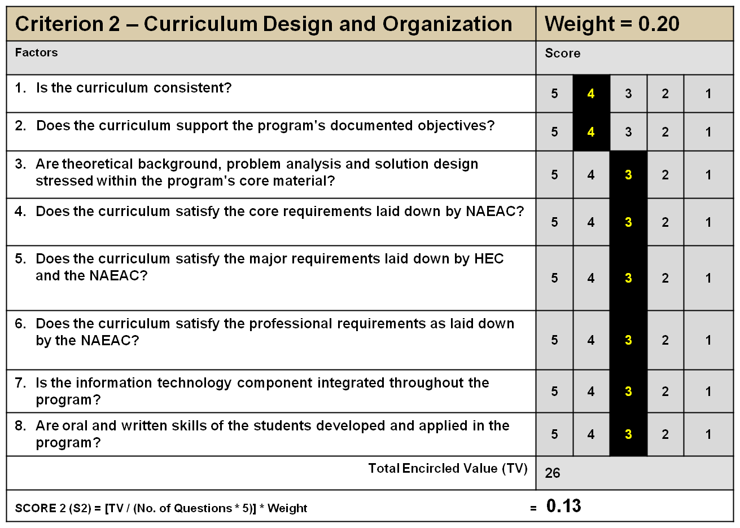
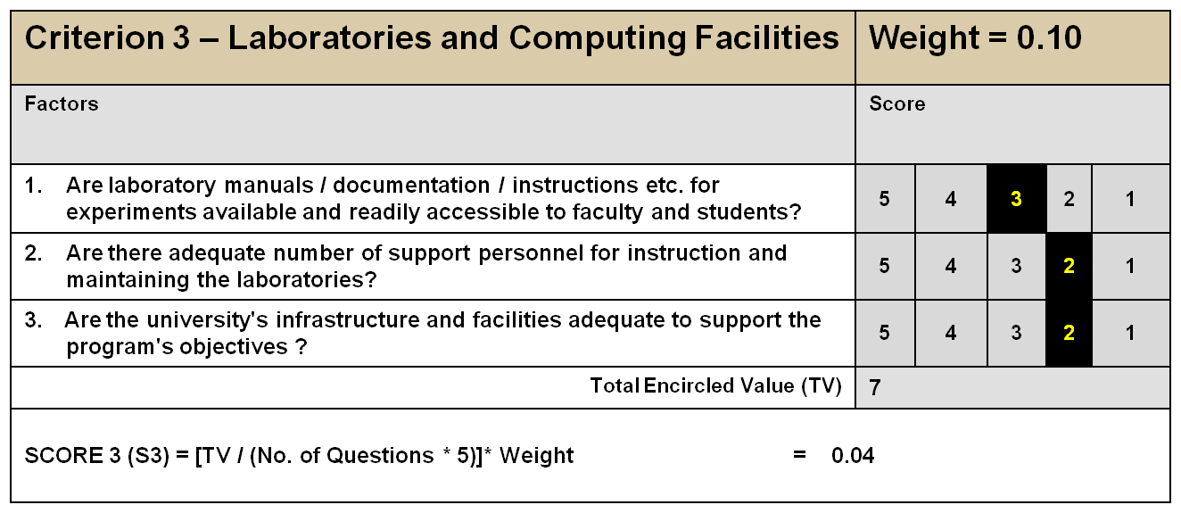
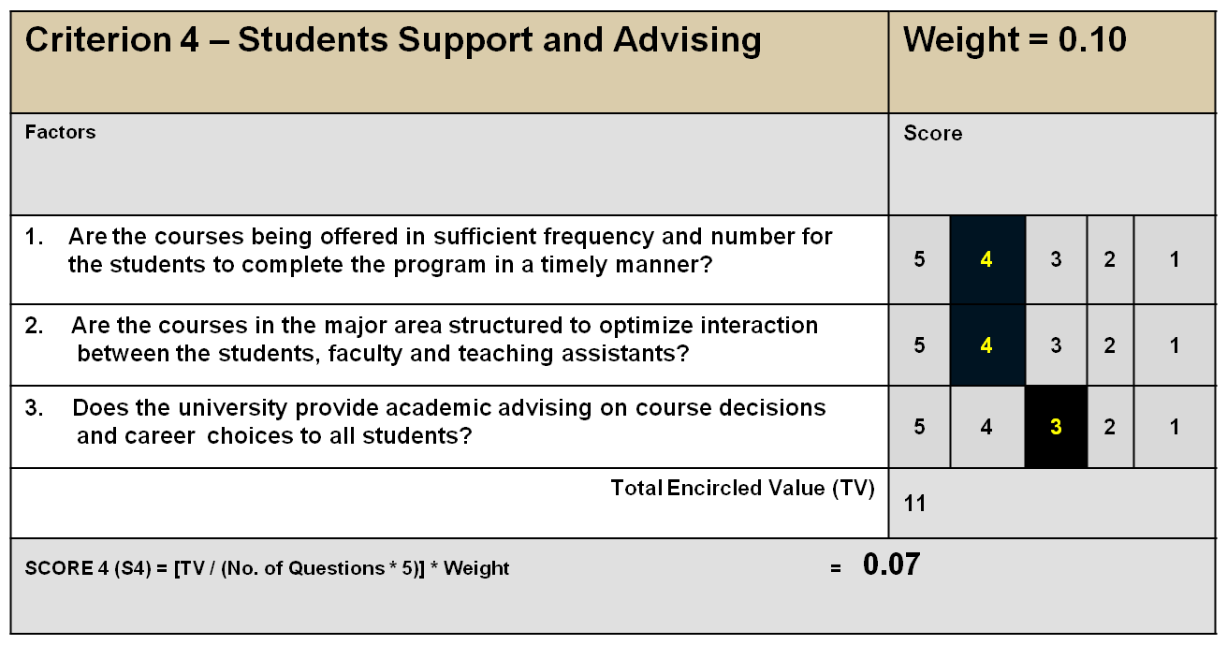

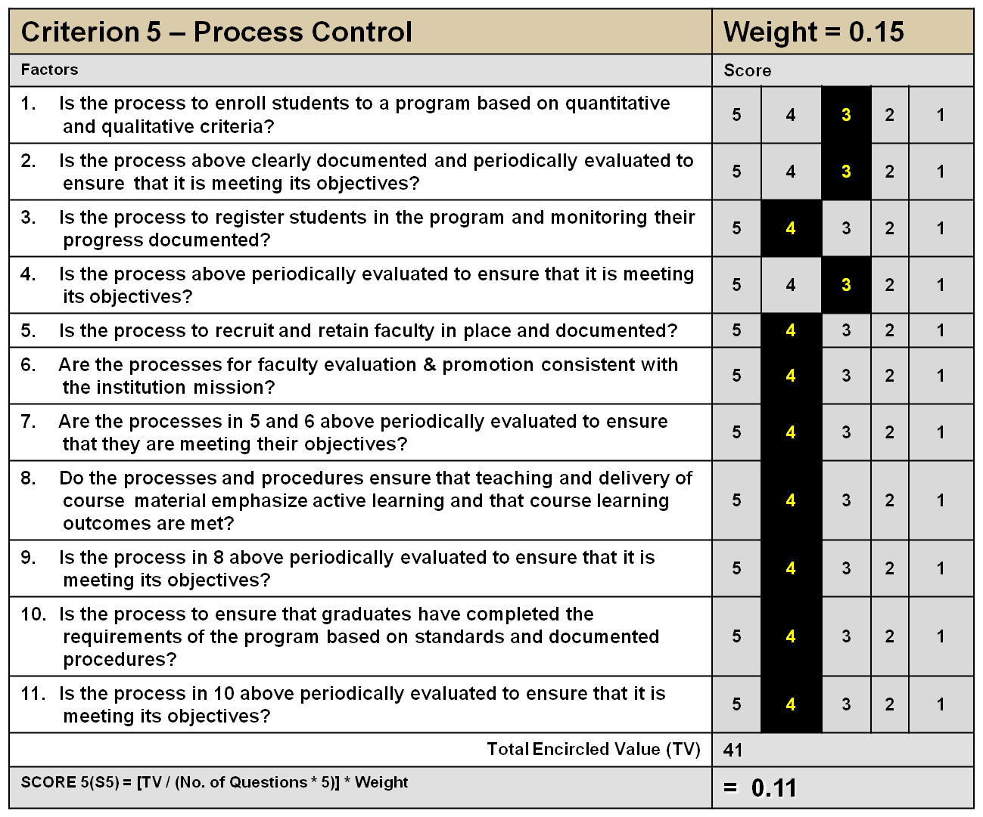

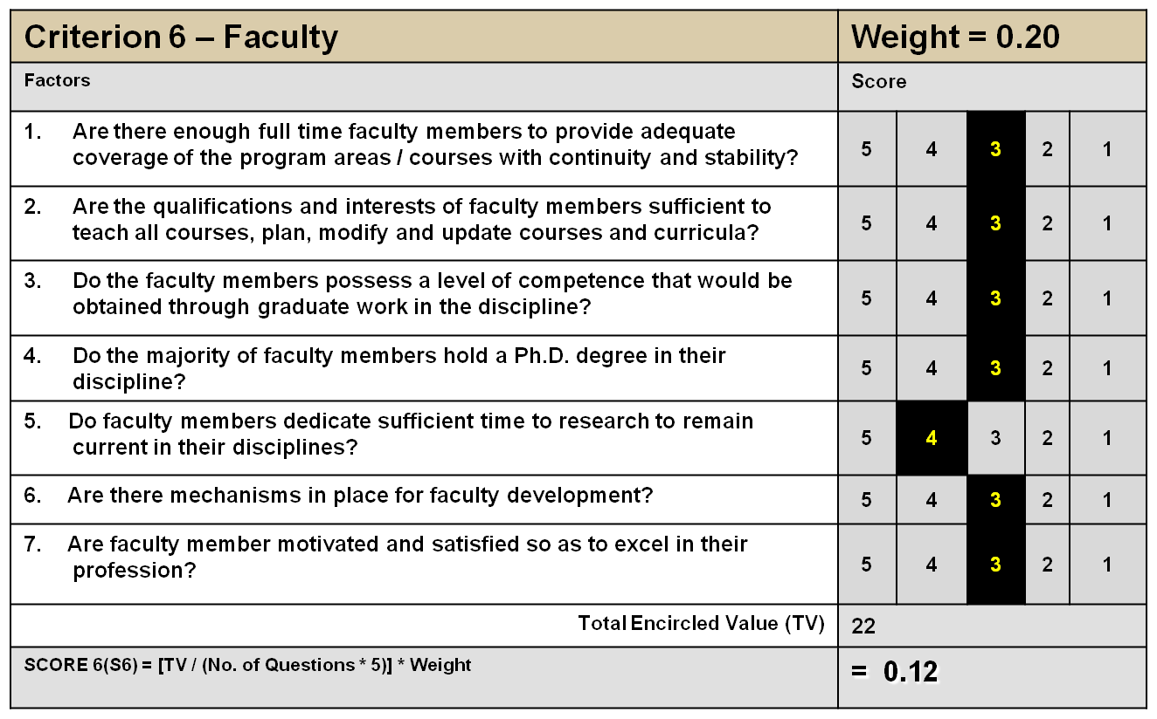
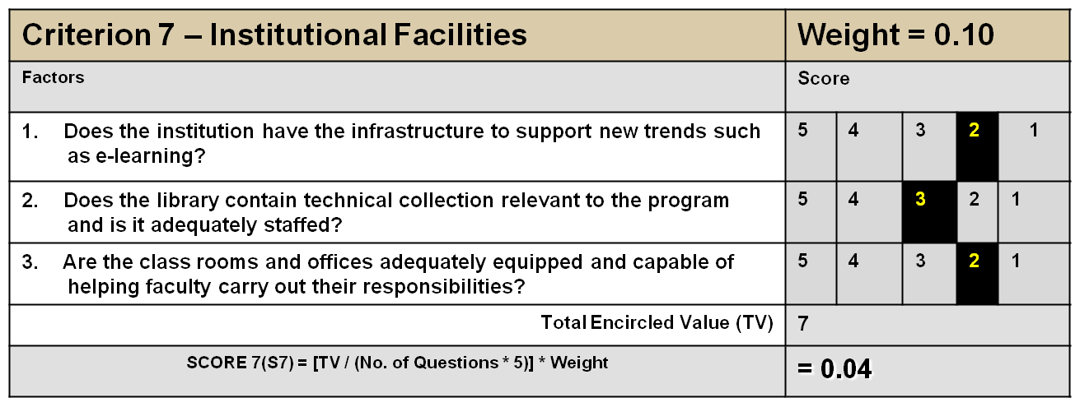

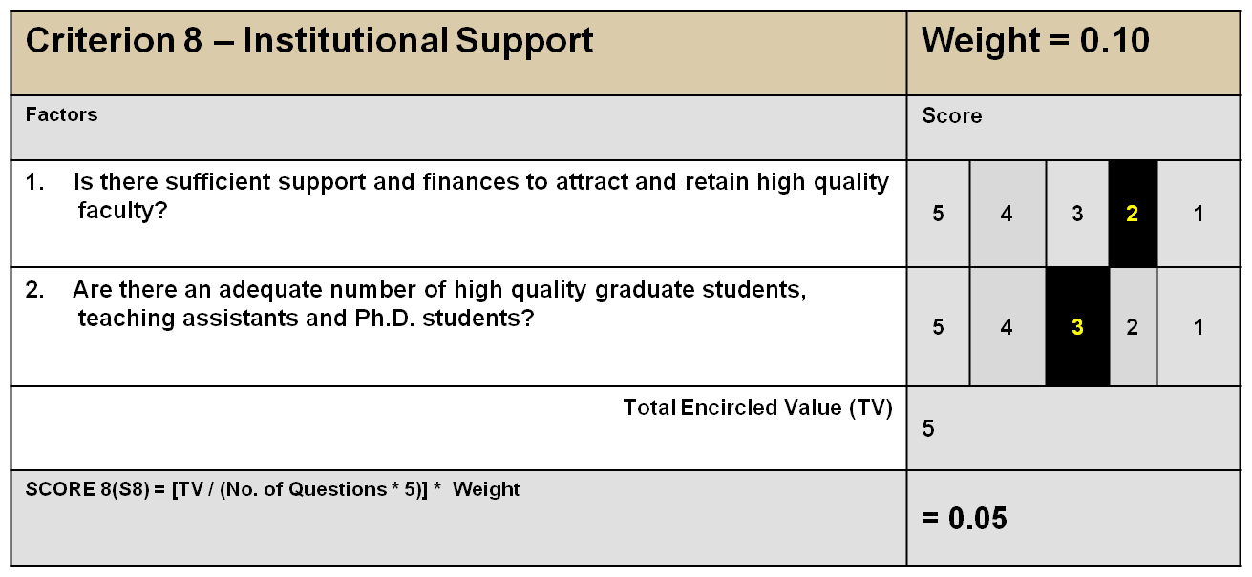

OVERALL ASSESSMENT SCORE:
S1 + S2 + S3 + S4 + S5 + S6 + S7 + S8 = 0.59
REMARKS:
Strengths
- Department has qualified teaching staff in specialization such as Food additives, post harvest technology, cereal sciences, fats and oil technology.
- The available equipments in our labs. are of the latest model use for research purpose.
- Income generate program has been started by the department, manufacturing and selling fruit products such as squashes and syrups.
- Department provide free consultancy services to ladies, farmers about preparation of various fruits products such as squashes, ketchup and syrups producing income generate.
- Limited scholarships for needy students.

Weaknesses
- Funds Autonomy to be given to the chairman of the department for students’ practical and research as well as other needs of the department.
- Qualified faculty needed in field of food microbiology, food biotechnology, food enzymology, food collides, food engineering food toxicology and beverage technology.
- To provide scholarship to department faculty for PhD and Post doc. study.
- Labs needed for further specialized courses of the department.
- Library, lecture rooms and computer labs needed at department level.
- Latest books and journals to be provided both to main library and department library as per need of the courses and research.
- Stipend to be provided to students for their compulsory internship as per curriculum.
- Faculty offices and committee room at department level needed.
- Study rooms for PhD scholars.
- Labs technicians are required.
- Needed training for new equipments to both faculty and Labs technicians.

